**WRITE UP FOR GUI (GRAPHICAL USER INTERFACE)**

OBJECTIVE: Creation of GUI (Graphical User Interface) for loading the image and predicts the defects type.

Procedure:

1.Importing the necessary libraries: Tinker, PIL, OS, etc.

2.Creating function of **Open Image**:It executes when “open Image” of GUI clicked by user. Then it opens the image by use of Image.open() function from PIL library Its then converted it into size of (250,250) by the ‘ImageTk.PhotoImage()’

It finally stores the label of image and then stores its path by use of ‘open_image.file_path’.

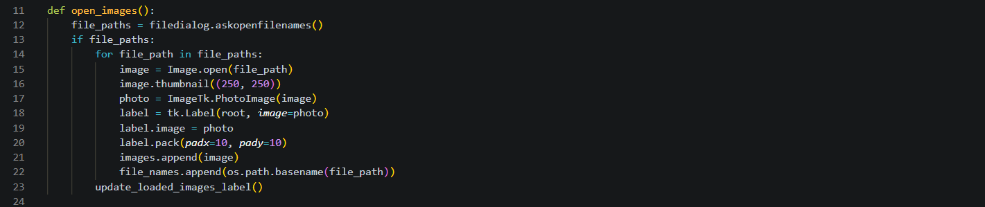

3.Creating function **check_defects():**This function is executed when the "Check Type of Defects" button is clicked. It retrieves the file path of the selected image from the ‘open_image.file_path’ attribute. Then it predicts the model the defect by pre-defined model. It maps the predicted digit to a corresponding defect name using a predefined list of cracks. Then it shows with the help of ‘show_defect_window()’.

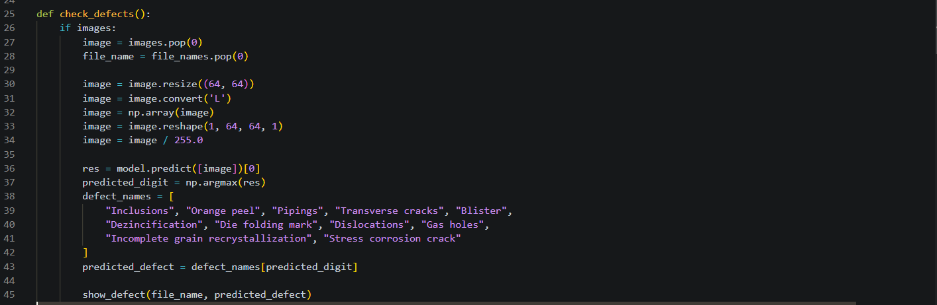

4. Creating function **show_defect and updated_loaded_image**:This function is used to show defects type and update corresponding number of images.

5. Making of GUI by **Tinker** library: Initializes the Tkinter root window (root) with the title "Defects Image Viewer". Creating buttons for opening an image and checking defects. List for the Images and corresponding labels are created to store the relevant data. The loaded_label function is used to show how many images are loaded. 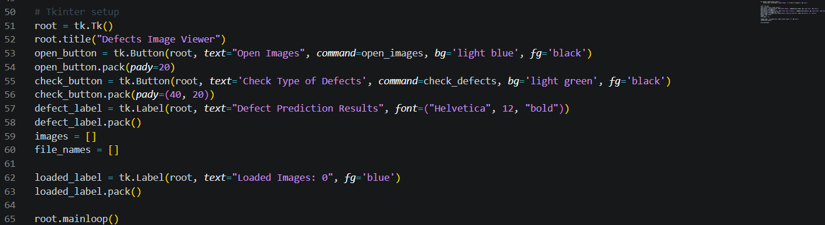

**WORKING:**

A user must first launch the GUI by simply clicking on the GUI icon on desktop. 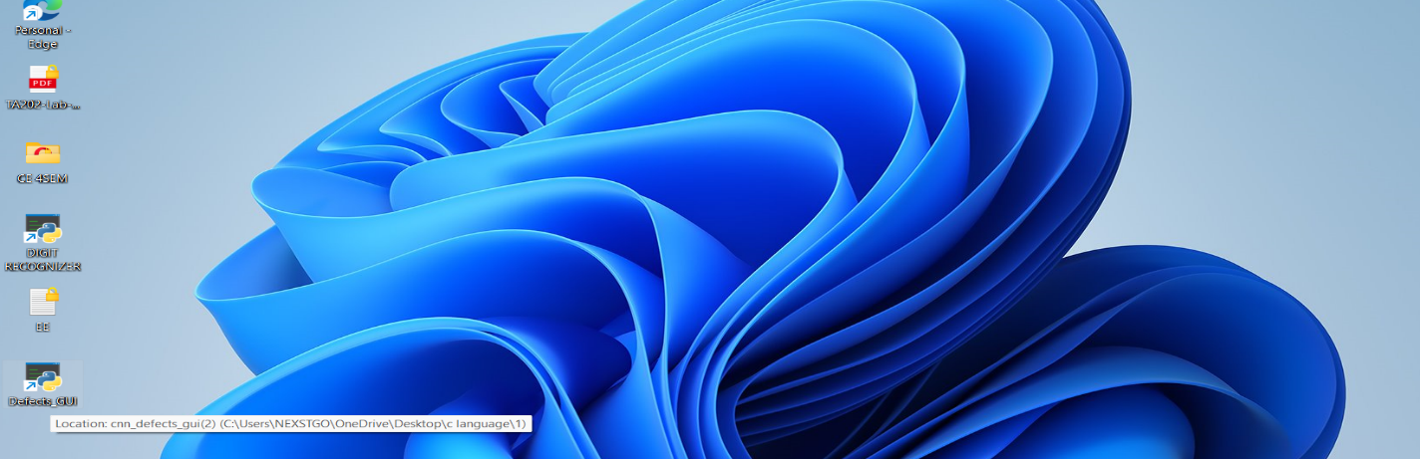

Following launch, it would appear as indicated below.

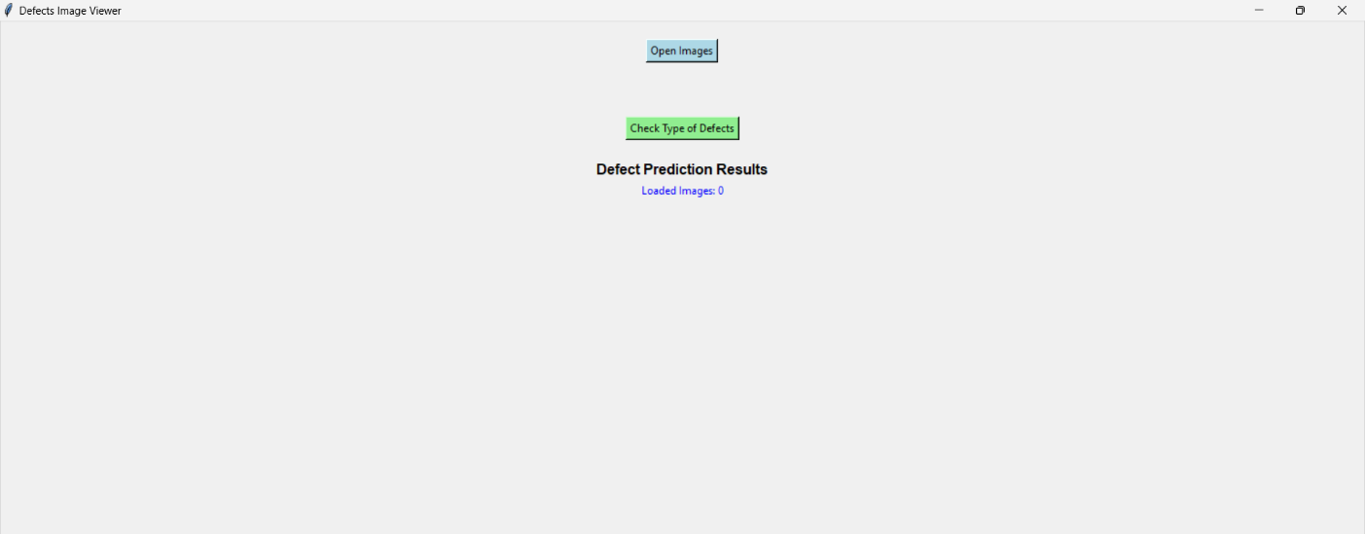

Next, upload the image by selecting the open image option next to the issue that must be anticipated. The user can load one or more images according to their needs.

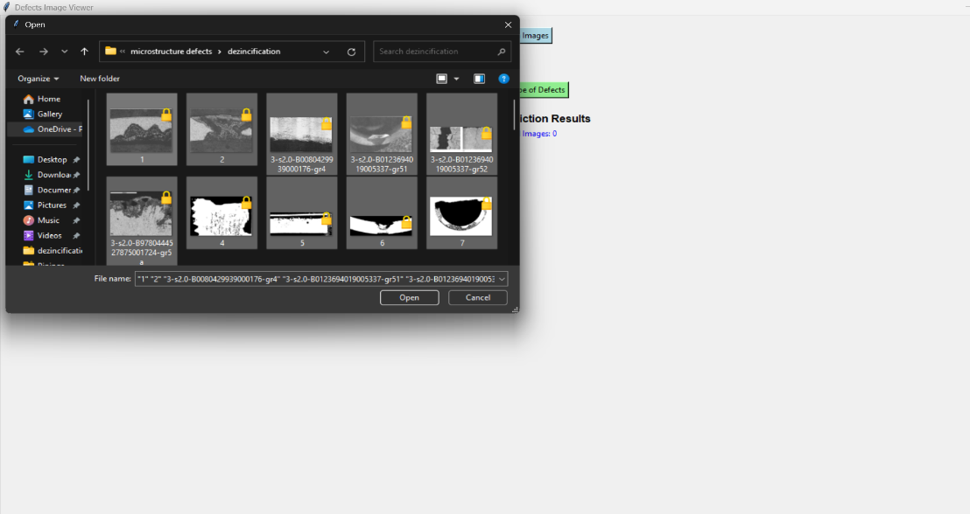

Then giving the check defects command will give you which type of defect it is based on model accuracy it also shows how many images have been uploaded and defects corresponding to that image.

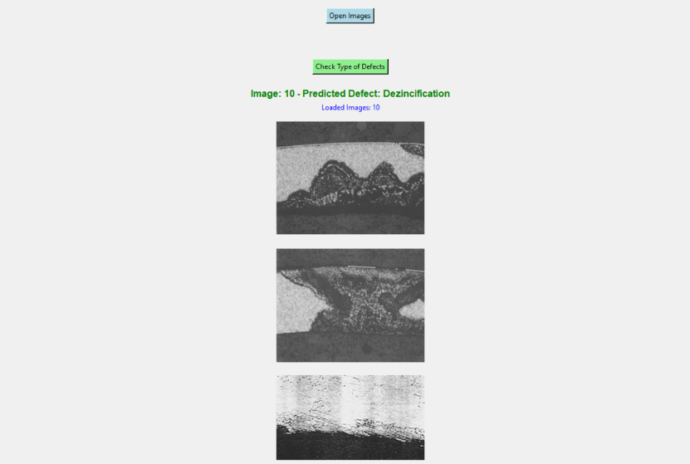

**CONCLUSION**

This GUI helps the user to easily predict the type of defects and can allow multiple images loading at a time which makes this model way more useful. The GUI developed aims to streamline the process of predicting defect types in images. Overall, this GUI empowers users to make informed decisions based on defect predictions, making it a valuable tool for defect analysis.